KA229 TURKEY MOBILITY PLAN
1 DAY
Welcome, Opening meeting
school tour
Ashura making workshop
Break (Food and Catering)
Scientists presentation: 1 Turkey (Aziz Sancar, Fuat Sezgin, Oktay Sinanoğlu, Uğur Şahin) 2. Lithuania
Break: Lunch
Scientists presentation 3 N.Macedonia
Introduction of scientists: 4. Serbia, 5 Romania
Governorship visit
Dinner (with Music)
2 DAYS
Public library
Anitkabir
Hamamönü
FOOD
Museum of Anatolian Civilizations
Hote
3 DAYS
Historical Beypazarı district
Living museum, Turkish Bath, Living village (Ebru-linden print)
Lunch
Shopping
Historical houses
4 DAYS
Nevşehir, Cappadocia
Breakfast on the Bus
Underground museum
Lunch
Hiking – Pottery
5 DAYS
Evaluation at school
Certification Ceremony
Cake cutting
Shopping

DAY 1
project opening ceremony
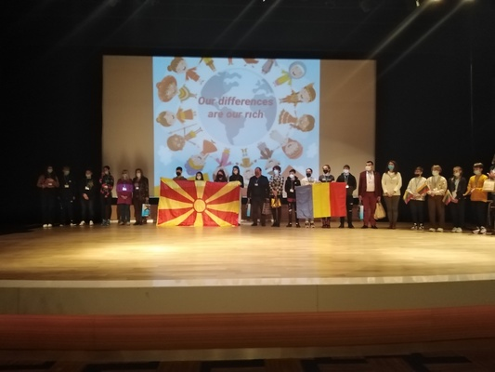

Ice break event
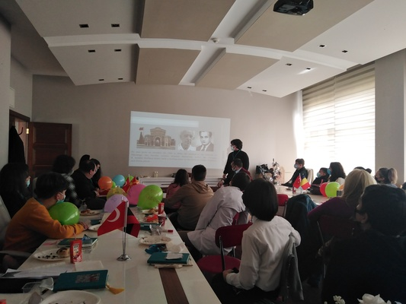

Aşure making activitiy
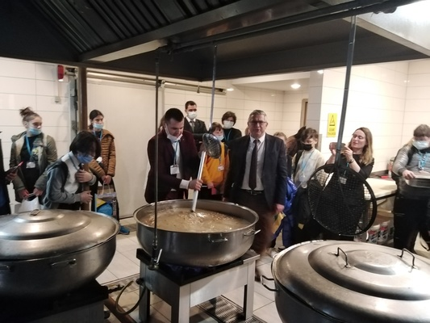

Scientists presentations
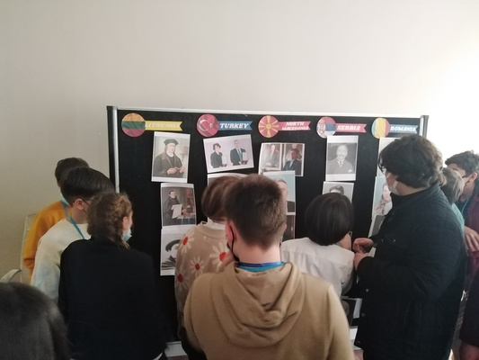

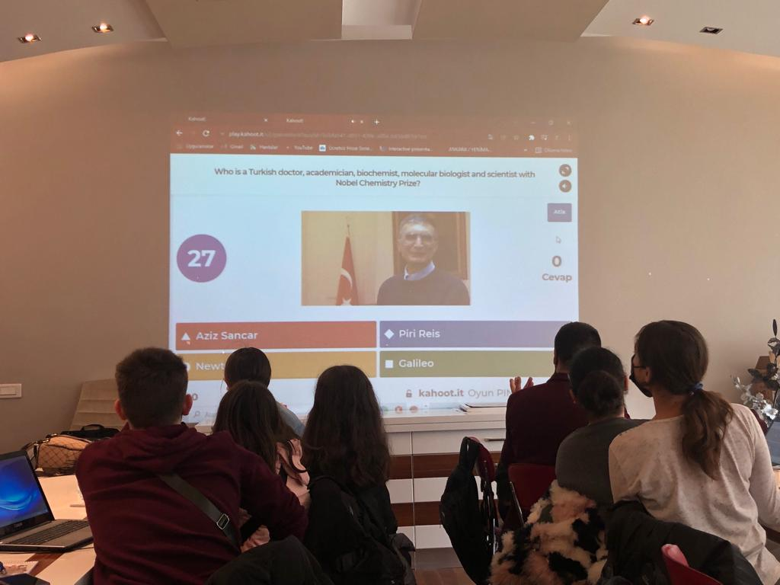

Semazen aktivity
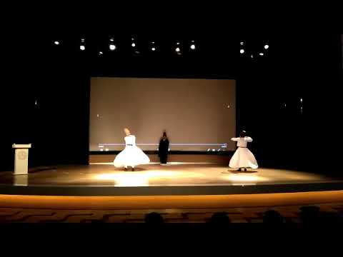
DAY 2
Lunc time
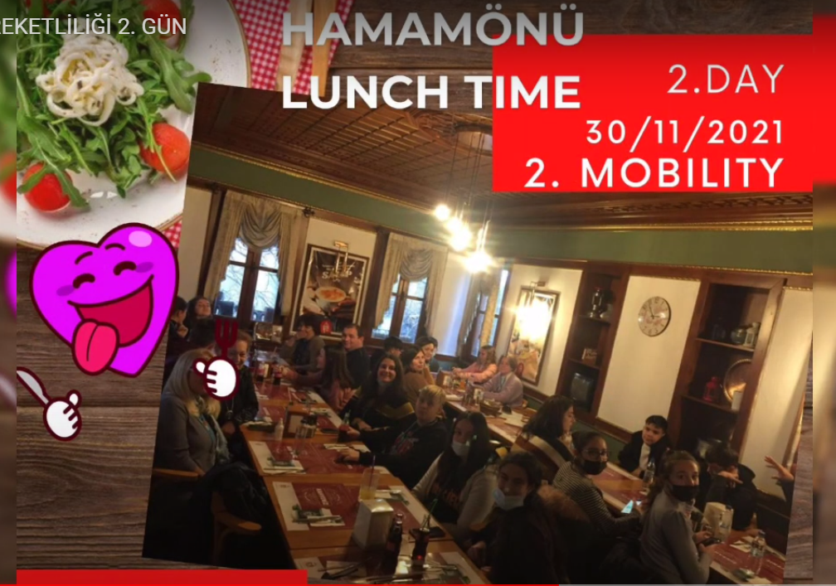

Anatolian Civilizations Museum Visit. The Anatolian Civilizations Museum, which has come to this day with its historical structures and deep-rooted history, was selected as the first among 68 museums in Lausanne, Switzerland on April 19, 1997, and received the title of "Museum of the Year in Europe".

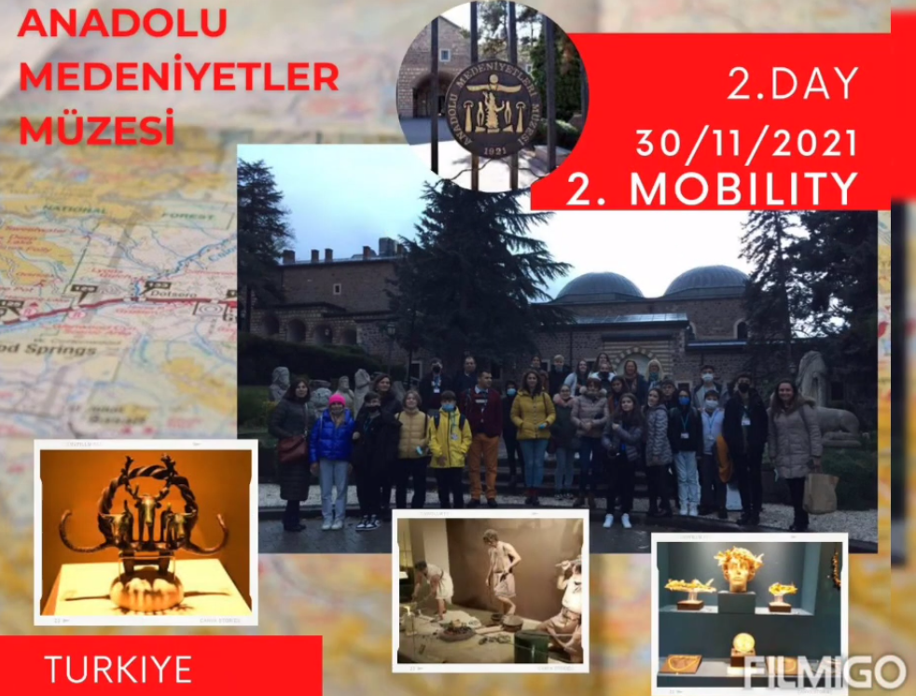

A trip was made to the National Library, Turkey's largest library, which was opened in 2015.
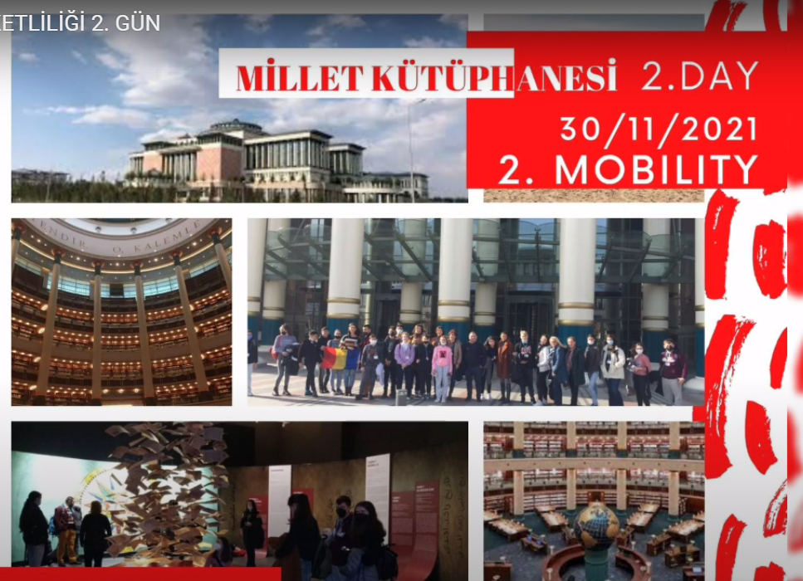

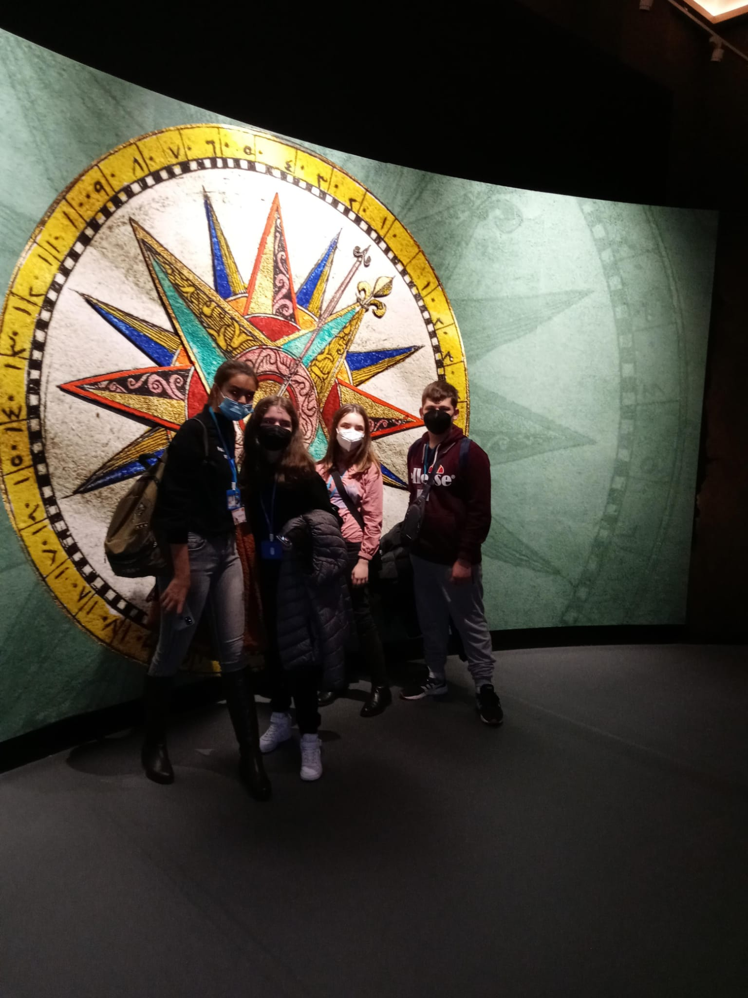

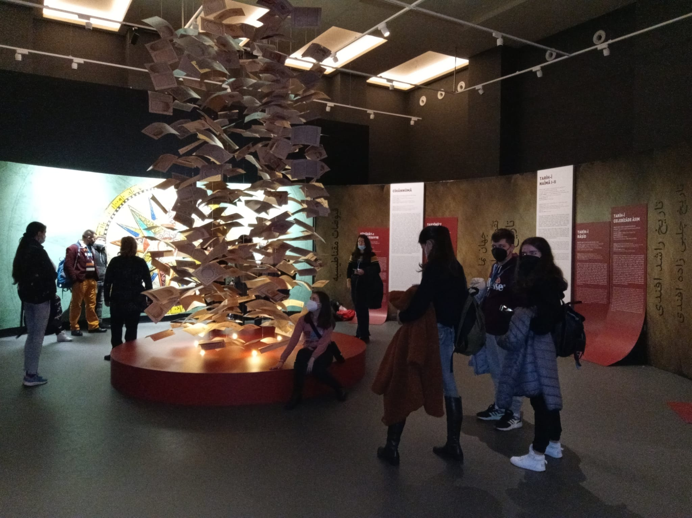

Visit to the mausoleum of Mustafa Kemal Atatürk, the founder of the Turkish Republic, and to the War of Independence Museum.
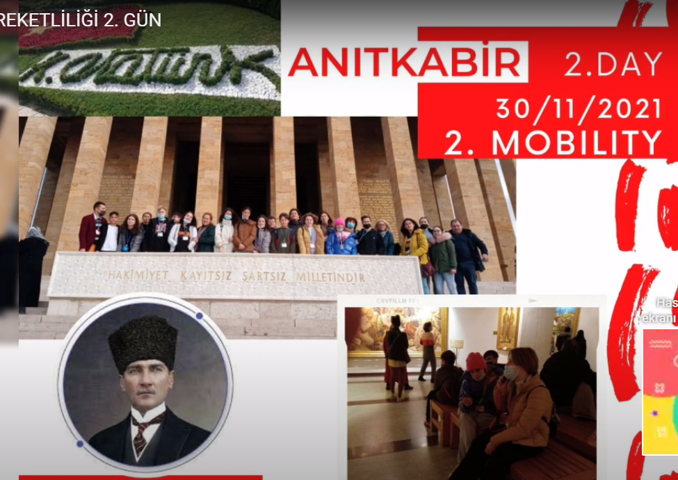

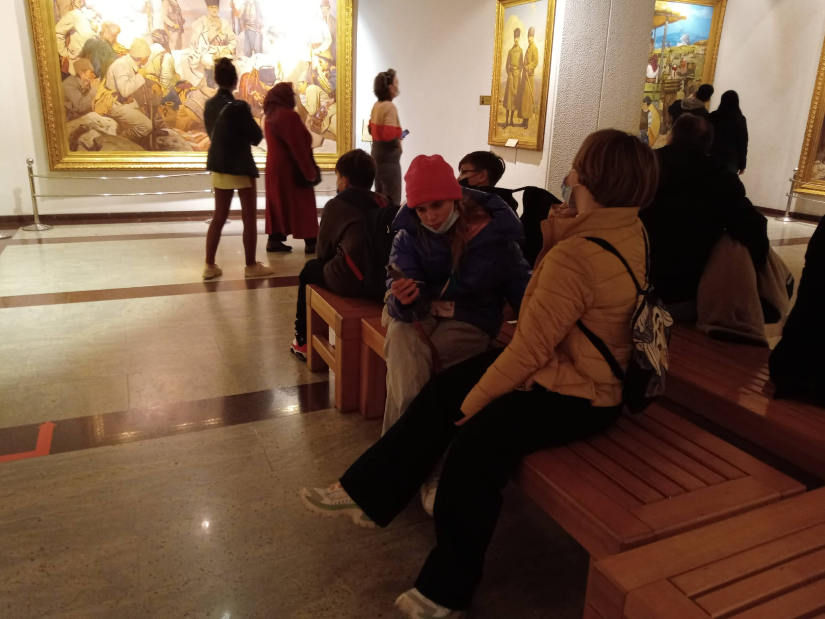

DAY 3- BEYPAZARI
A trip was made to the Bypazarı district of Ankara. Local house architecture was learned during the excursions of historical ankara houses. Turkish culture was learned by visiting the Living Museum. The art of marbling (Ebru)and Ihlamur printing were made on the fabric. traditional Turkish dishes were eaten.
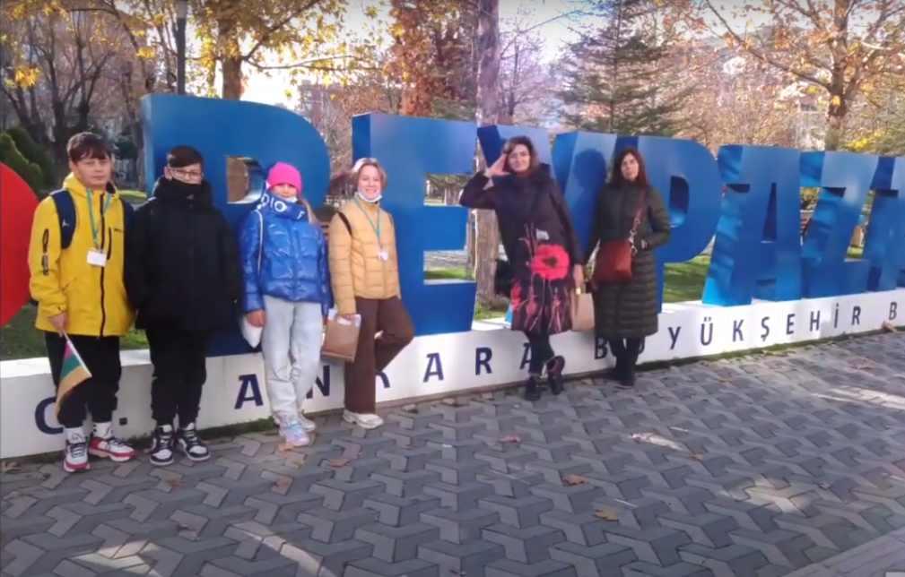

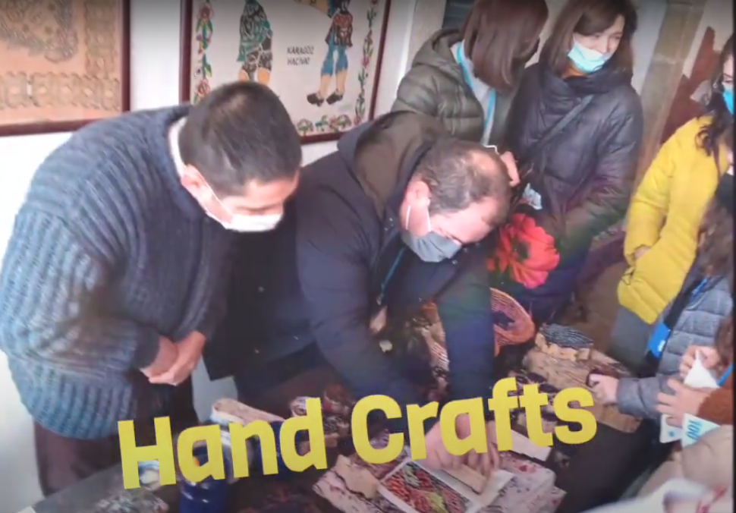

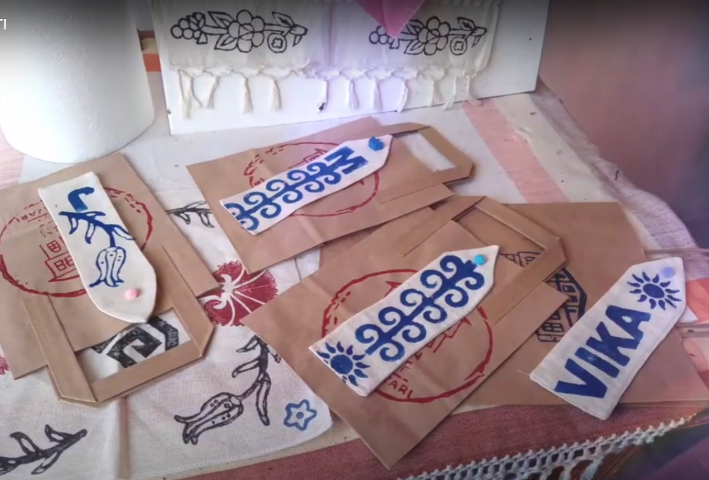

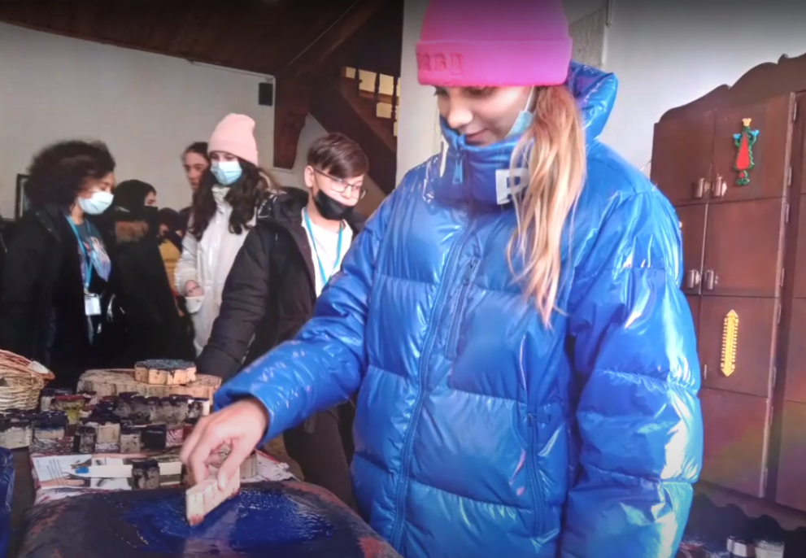

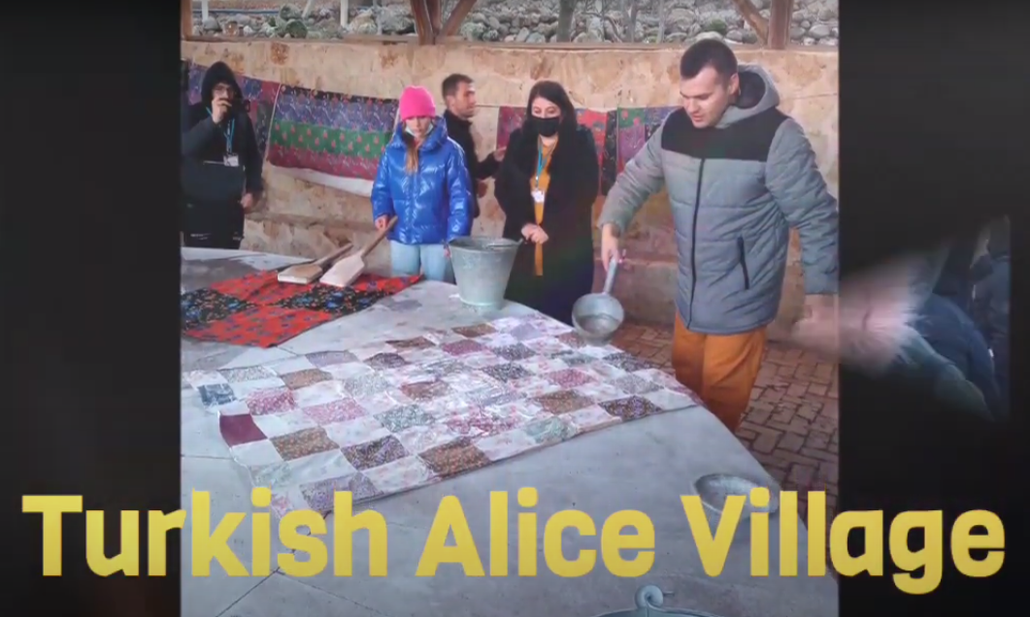

DAY 4
A pottery event was held in Cappadocia.
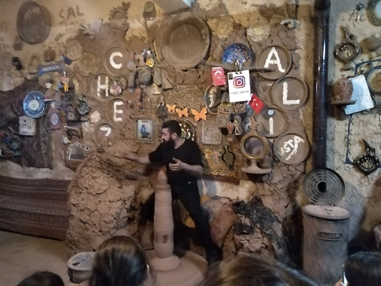

Fairy Chimneys in Göreme Open Air Museum were visited
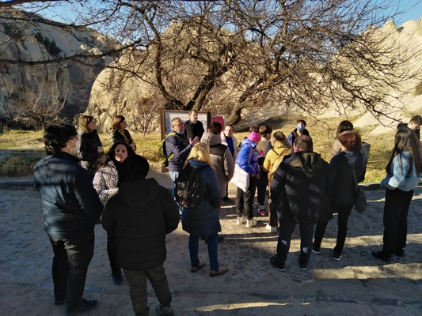

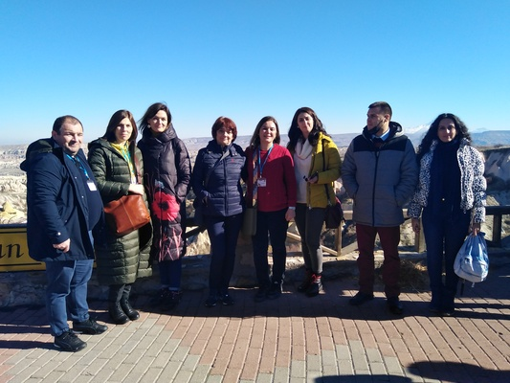

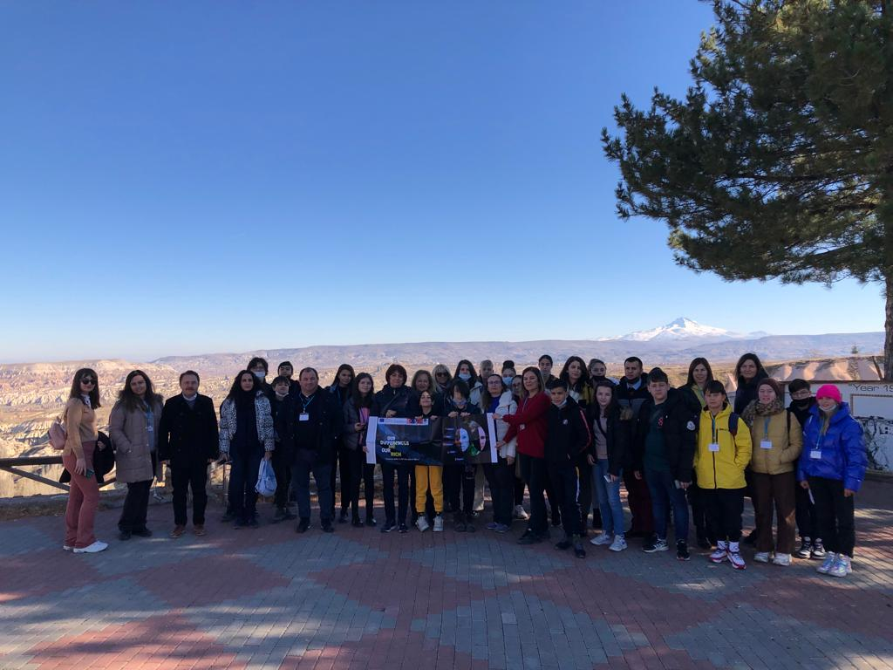

Kaymaklı underground cave was visited.
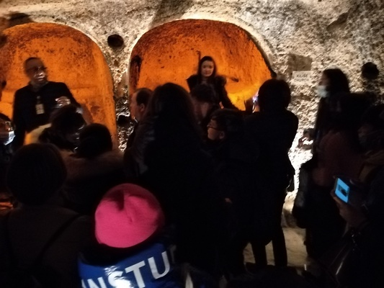

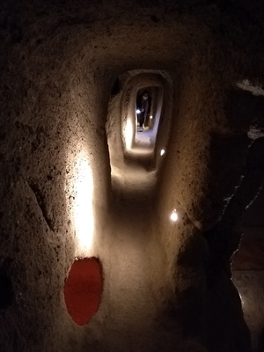

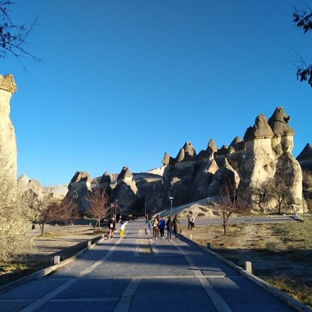

DAY 5
Our project song was written and sung by participating students from all countries.
Our Project Song
https://youtu.be/S7KCBzKonPA
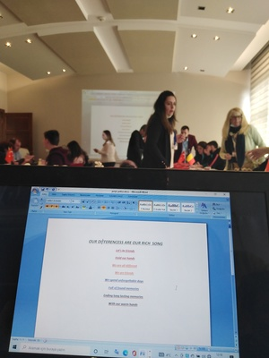

Student-teacher assessment was made about Turkey's mobility. Mentimeter tool was used for evaluation.
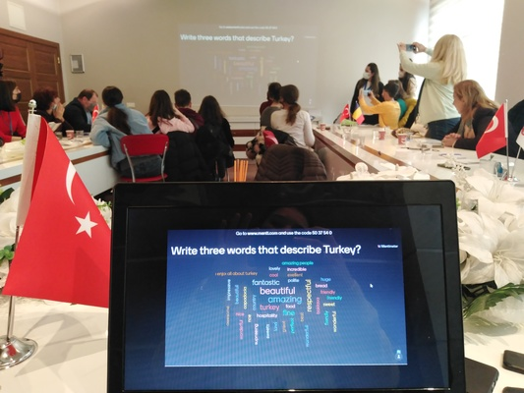

Project cake cutting event on closing day
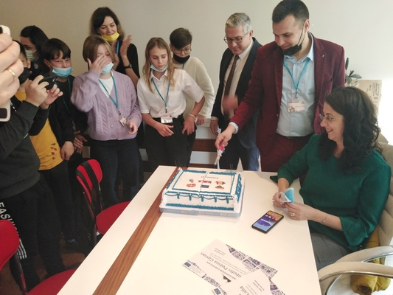

Certificate ceremony was held
